[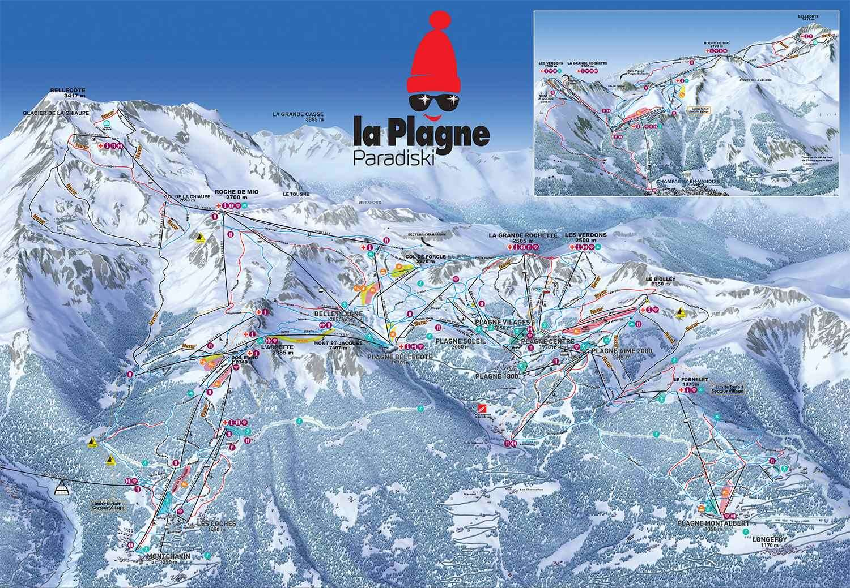](https://www.google.co.uk/url?sa=i&rct=j&q=&esrc=s&source=images&cd=&cad=rja&uact=8&ved=0ahUKEwilxIStnfDXAhULORQKHSAUAWUQjRwIBw&url=https://www.igluski.com/ski-resorts/france/belle-plagne/piste-map&psig=AOvVaw3TNskkOBcI0VUJx6ow5ae2&ust=1512472519537523)